**Mahatma Gandhi College**

**Department of English**

**Newsletter 2024-25**

1. **Intellectual Property Rights**

**Date: 13/08/2024 Venue: Seminar Hall**

Intellectual Property Rights (IPR) are legal rights that protect creations of the mind, ensuring that people get recognition and control over their inventions, artistic works, and designs. IPR encourages innovation by giving creators exclusive rights over their work for a certain period. A session was organised for the students of the Department of English to enhance their awareness regarding the concept of intellectual property Rights. It also discussed major IPR types like Patents, Copyrights etc.

The session was handles by Dr Vimal Kumar, Reference Assistant, MG University,Kottayam.

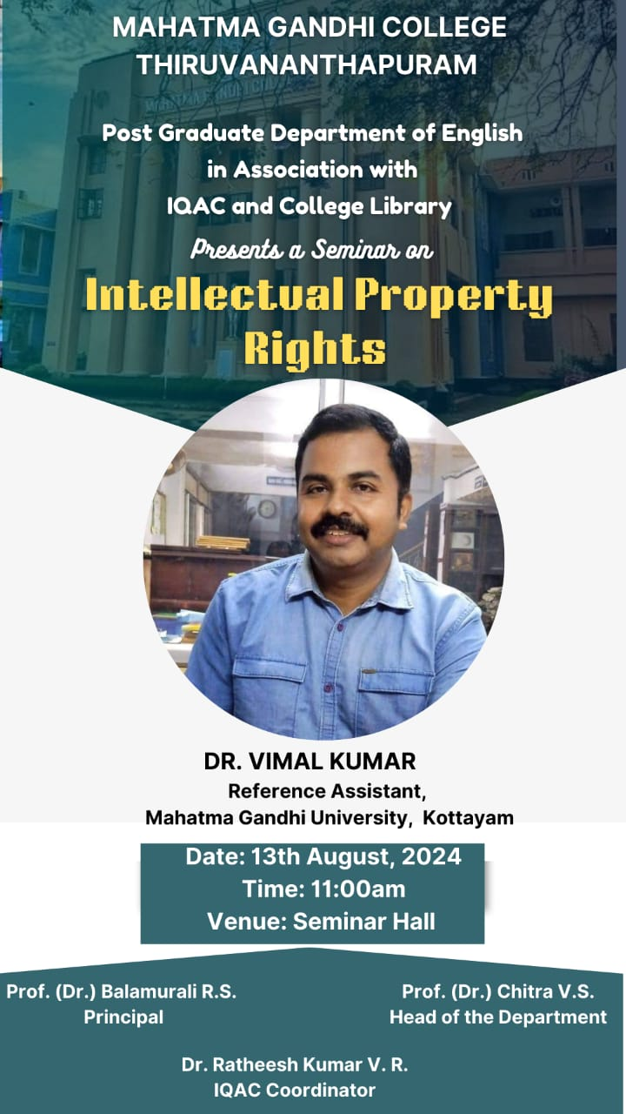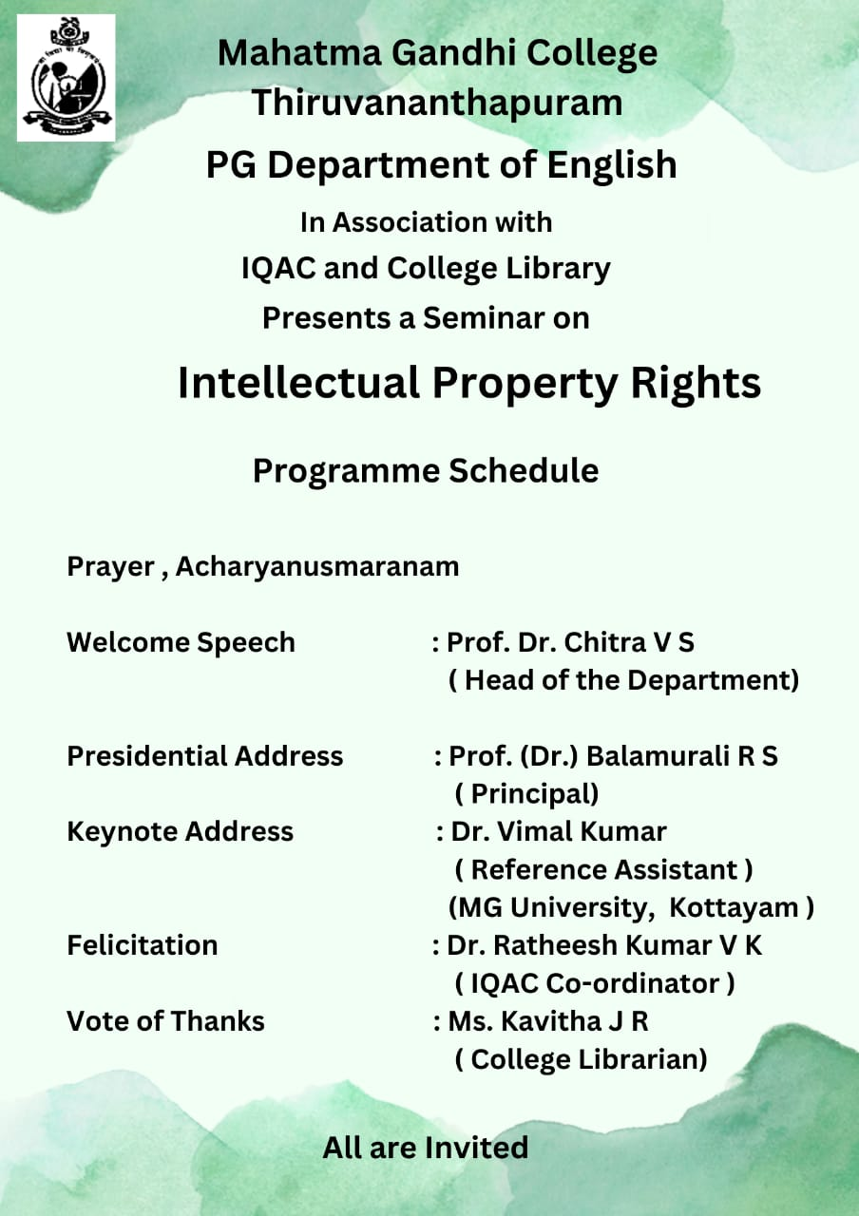

1. **Reading Media: A cultural and Semiotic Approach**

**Date:19/08/2024 Venue: Seminar Hall**

The topic was intended to explore how media content—such as films, advertisements, and digital platforms—conveys meaning through symbols, signs, and cultural contexts. This approach, rooted in semiotics, analyses how audiences interpret messages based on their cultural backgrounds and experiences. It examines how visual and textual elements shape perceptions, influence ideologies, and reflect societal values. By decoding media through this lens, we gain deeper insights into how communication shapes identities, beliefs, and global narratives. The session was handled by Prof.(Dr.)Saji Mathew, Director Professor, School of Letters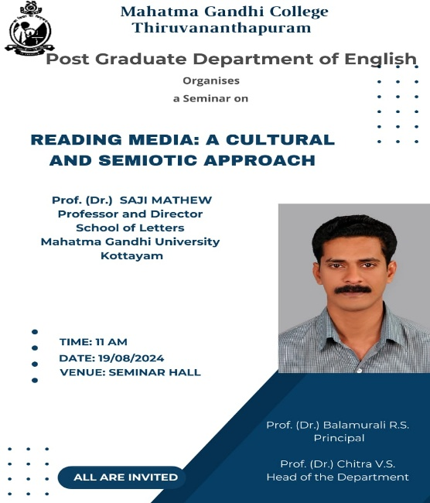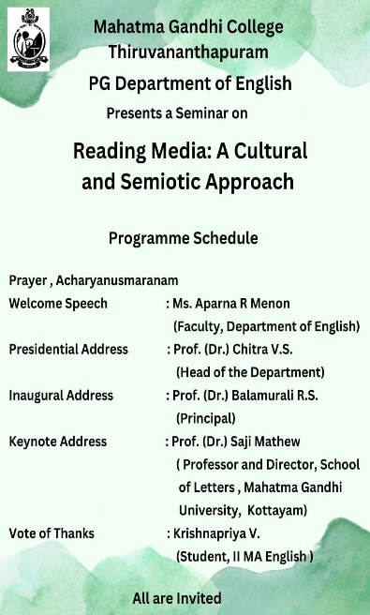

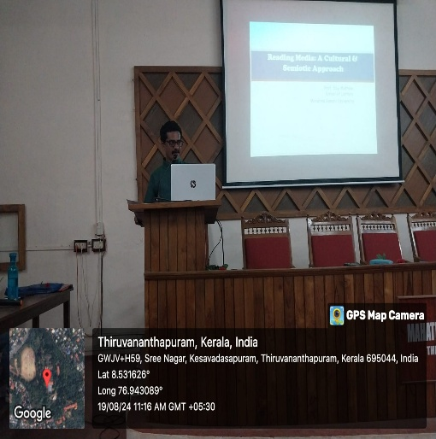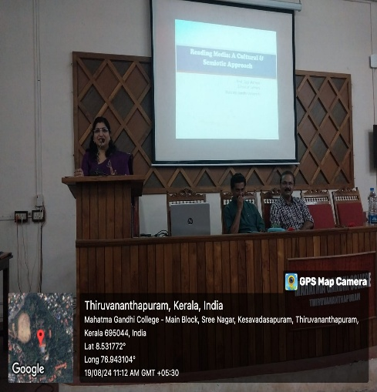

1. **Research Methodology**

**Date: 05/09/2024 Venue: Seminar Hall**

This session was intended at increasing the final year UG and Post Graduate students regarding the nuances of research. Research methodology refers to the systematic approach used to conduct research, including the techniques, tools, and processes for collecting, analysing, and interpreting data. It ensures the study is structured, reliable, and valid. Key components such as research design, data collection methods, sampling techniques, and analysis procedures were discussed. It was implied that a well-defined methodology helps in drawing accurate conclusions and contributes to the credibility of the research findings. The session which was extremely beneficial to the students was handled by Dr Divya C Senan, Assistant Professor, Department of Education, University of Kerala.

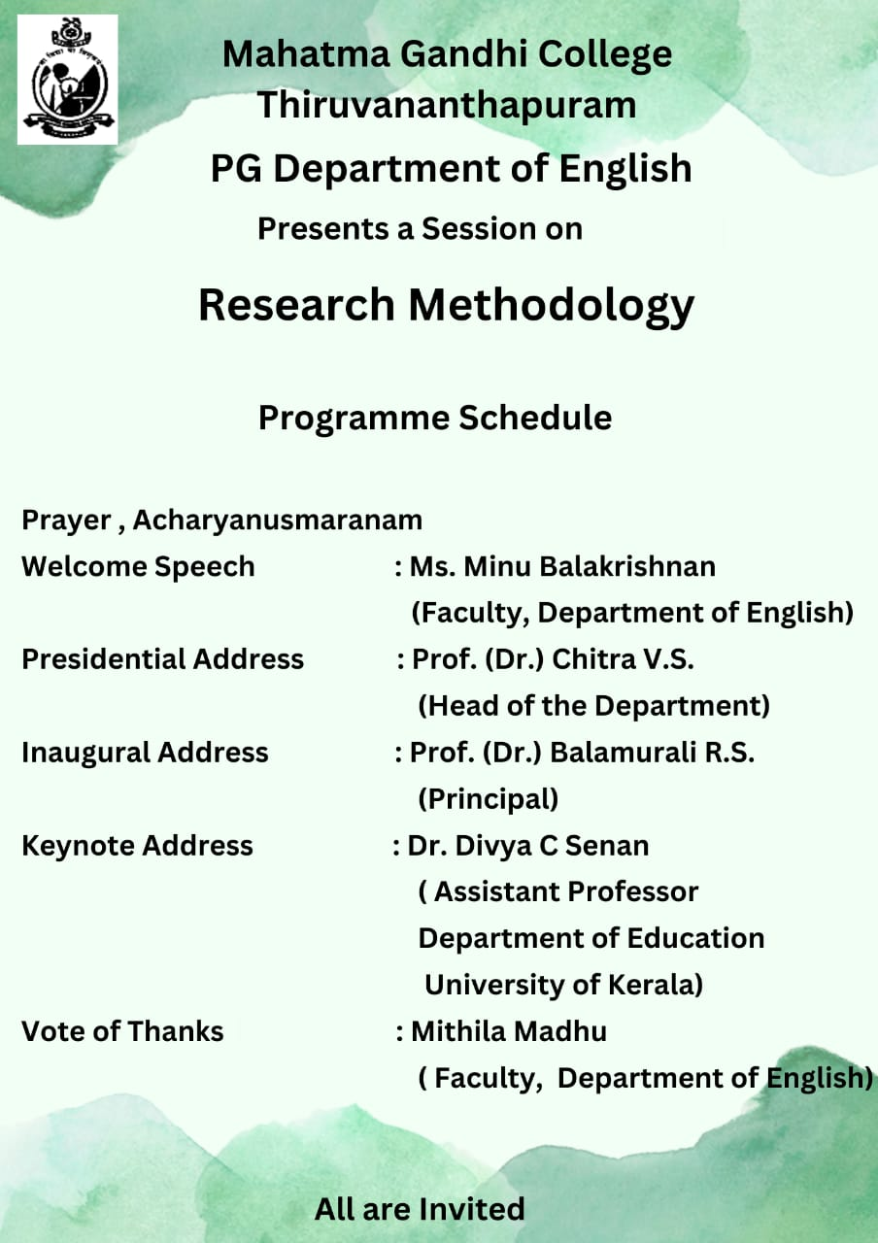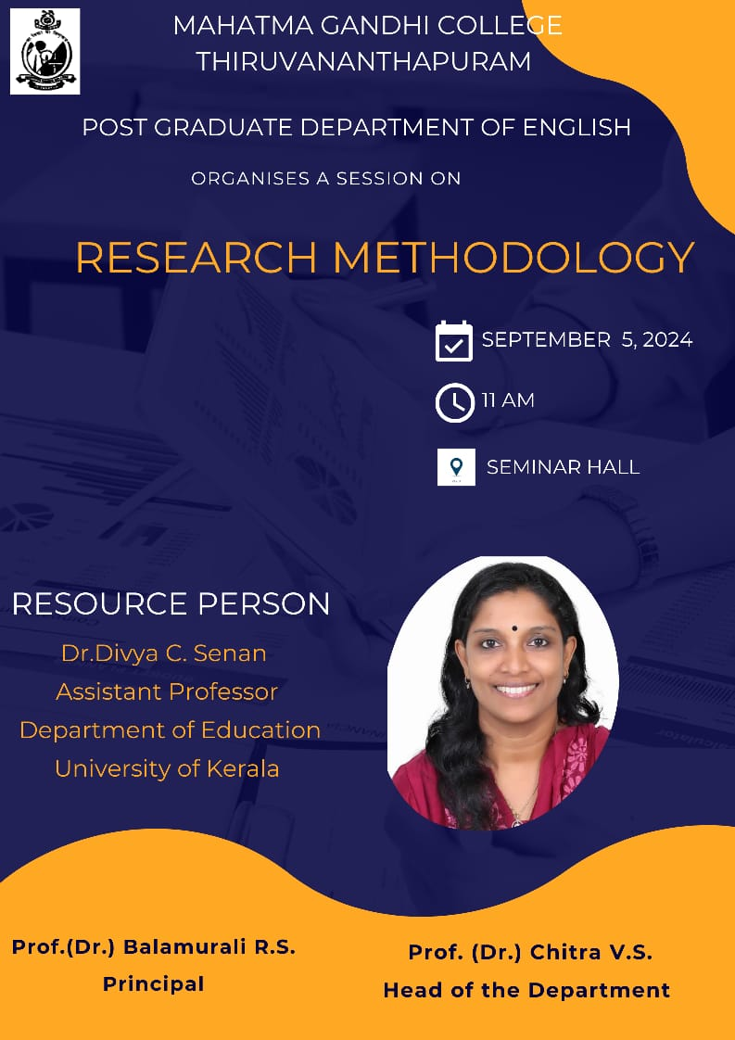

1. **Alumni Endowment Ceremony**

**Date: 29/10/2024 Venue: Seminar Hall**

The alumni batch of 1982 B A English visited their Alma Mater and as a contribution of their relation with the department they gave a cash award to the topper of the 2023-24 academic year. Around 20 alumni visited the campus and department . they had a session with the students were they shared their valuable insights and delighted the students with stories of fond memories of the time spent in this institution. They were also able to narrate stories about hoe the department library was set up, their contribution and many anecdotes.

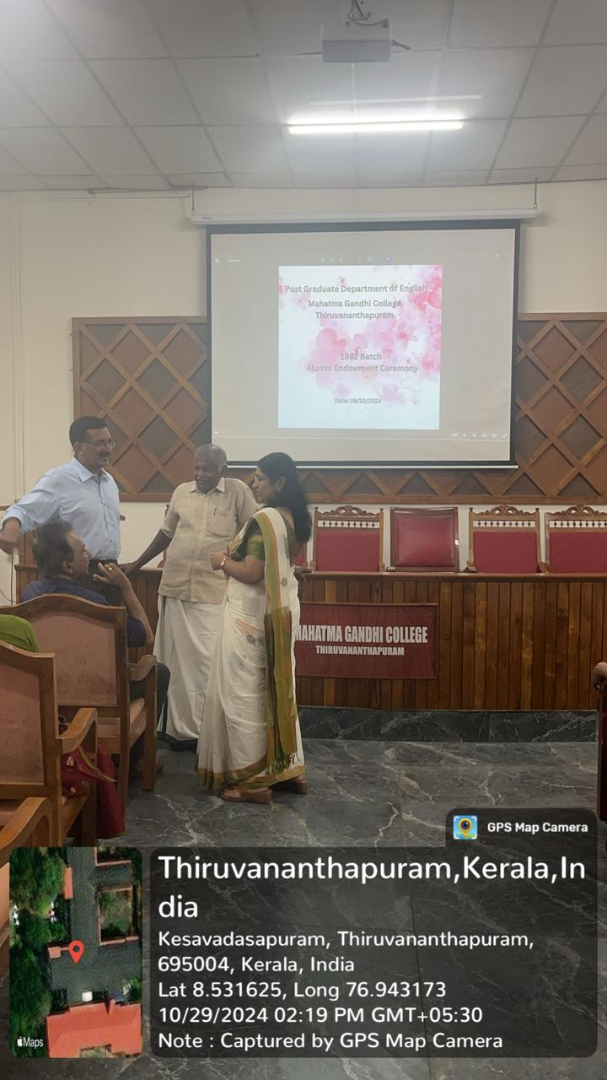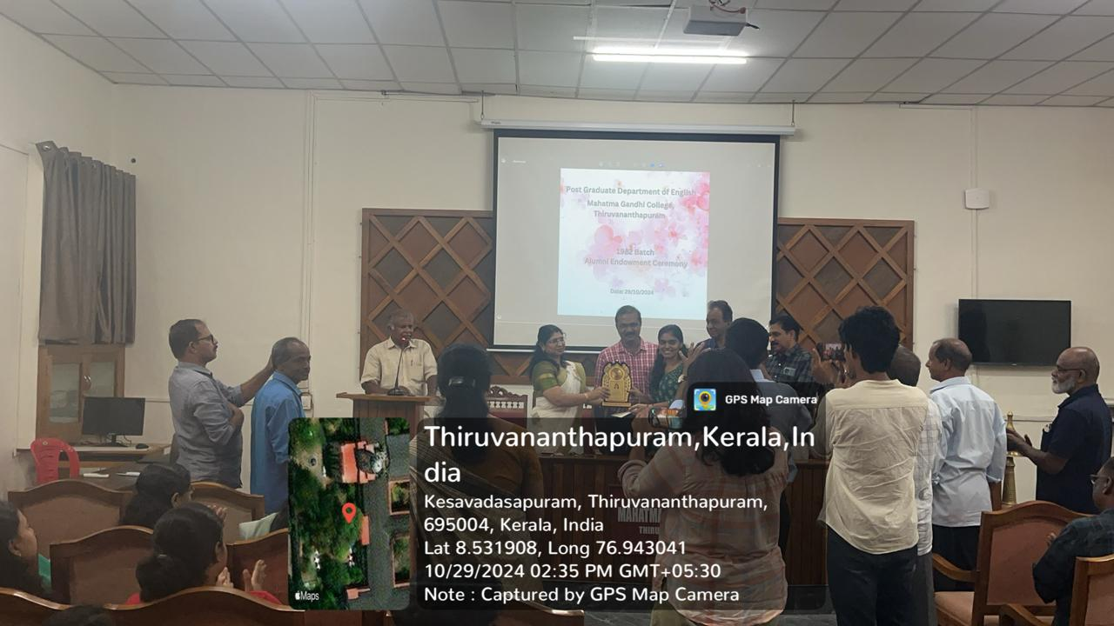

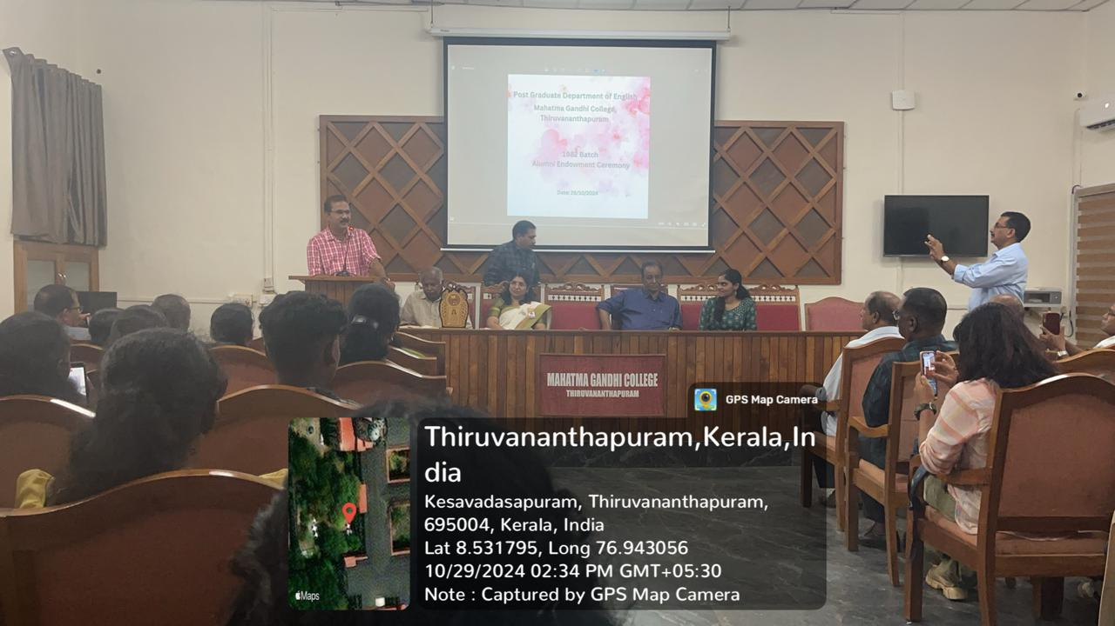

1. **Fortifying Integrity Vigilance Awareness**

**Date: 08/11/2024 Venue: Seminar Hall**

Integrity, vigilance, and awareness are crucial pillars for building a just and ethical society. Integrity ensures honesty and moral uprightness in personal and professional life. Vigilance helps in identifying and preventing corruption, fraud, and unethical practices. Awareness empowers individuals with knowledge, enabling them to make informed decisions and stand against wrongdoing. Strengthening these values creates a transparent and accountable system, fostering trust and responsibility in all aspects of life. Theses important concepts were dealt in detail by Saji Kumar CI, Vigilance and anticorruption Bureau, Government of Kerala.

1. **Alumni Interaction Series- I. Introduction to Critical Theory**

**Date: 13/11/2024 Venue: Room 75**

Critical Theory aims to promote social change by encouraging individuals to critically analyse their surroundings, question authority, and challenge oppression. It is widely applied in literature, politics, media studies, and sociology to explore issues like capitalism, gender, race, and technology’s role in shaping society. it is a philosophical and social approach that examines society, culture, and power structures to uncover hidden inequalities and injustices. Originating from the Frankfurt School in the early 20th century, it challenges dominant ideologies and questions how power influences knowledge, media, and institutions. As part of Alumni Lecture this session was handled by Devika A A, an alumni of the department of English. MA 2019-21 batch. She was able to intrigue the students by engaging them in a very interesting conversation about critical studies.

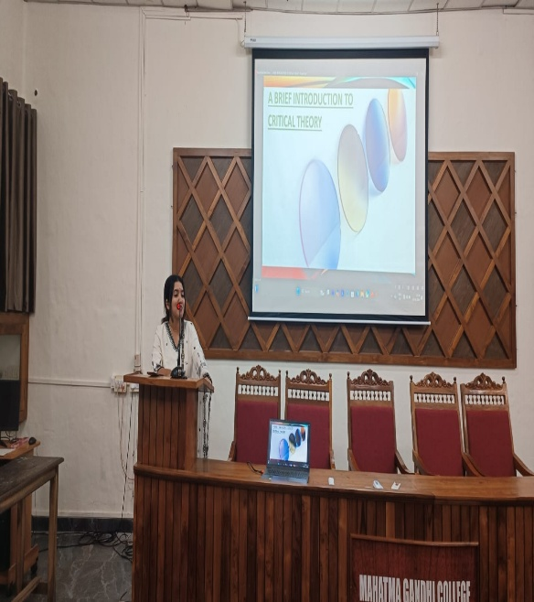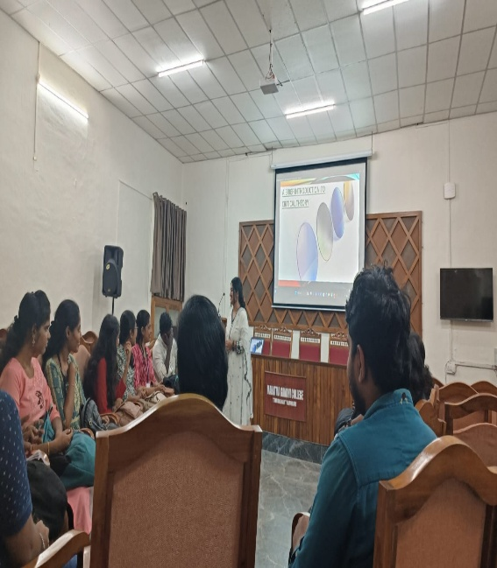

1. **Gender Based Violence**

**Date: 4/12/2024 Venue: Seminar Hall**

The session was organised as part of the 16 Days of Activism against gender based Violence Campaign. The talk was an initiative at making the students aware of the different types of Violence that they can become victims of. She emphasised upon gender as a power structure which ensues from the dominance of various religious and cultural norms and how we without being aware become victims of this generalisation. She also talked about the kind of violence in educational institutions, workplace and home. Violence in domestic and work sector as well as violence faced by women in public places. She also fleetingly mentioned about how the men too face violence but the number of reported cases being extremely less is also a symbol of how society tries to maintain the power hierarchy by not revealing these numbers. In all it was an extremely informative and useful session for the students.

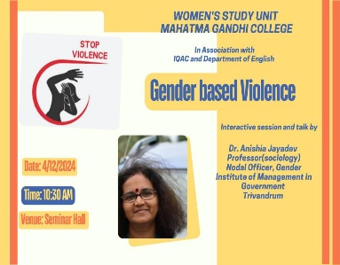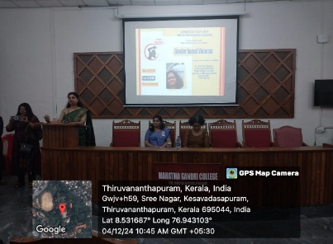

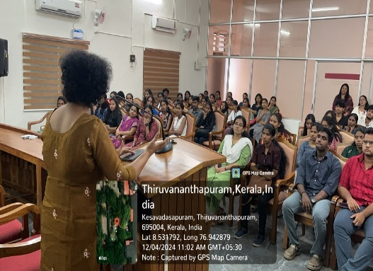 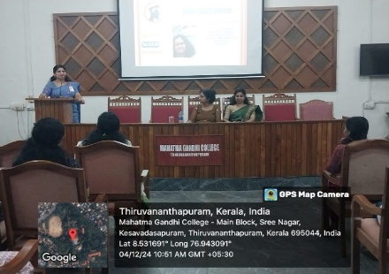

1. **Christmas Celebration**

**Date: 19/12/2024**

Celebrating festivals in educational institutions plays a vital role in promoting cultural awareness, unity, and holistic development among students. It fosters inclusivity and respect for diverse traditions, helping students appreciate different cultures and values. Festivals also create a joyful learning environment, reducing academic stress and enhancing creativity through art, music, and performances. They encourage teamwork and social bonding, as students collaborate in organizing events. Additionally, such celebrations instil moral values, teaching students about traditions, history, and the importance of togetherness. Overall, festivals in schools and colleges enrich the learning experience, making education more engaging and meaningful. With the purpose of achieving such goals Christmas was celebrated in the department.

1. **Alumni Interaction Series – II. Post Modernism**

**Date: 8/01/2025 Venue:Seminar Hall**

Postmodernism is a broad intellectual movement that emerged in the mid-to-late 20th century as a reaction against modernist ideas of absolute truth, progress, and rationality. It challenges established norms, questioning objectivity, grand narratives, and fixed meanings. Instead, postmodernism embraces relativity, diversity, and subjective interpretations in areas like literature, art, philosophy, and architecture. Thinkers like Jean-François Lyotard, Jacques Derrida, and Michel Foucault argued that knowledge is socially constructed and influenced by power dynamics. Postmodernism is marked by irony, scepticism, and an emphasis on individual perspectives, making it a key framework for analysing contemporary culture, media, and identity. This area was deftly handled by Ms Ganga Satheesh, MA 2021-23 batch alumni.

1. **Basics In Yoga**

**Date: 28/01/2025 Venue: Seminar Hall**

Yoga is a holistic practice that enhances physical, mental, and emotional well-being. It improves flexibility, strength, and posture, while also reducing stress and anxiety through breathing techniques and meditation. Regular practice boosts concentration, self-discipline, and inner peace, promoting a balanced lifestyle. Yoga also strengthens the immune system, aids digestion, and enhances overall health. By integrating mind and body, yoga fosters self-awareness and harmony, making it essential for a healthy and stress-free life. To instil this life skill among the students the department organised a session on basics of Yoga. The session was Handled by Dr. Asha AI, Assistant Professor, Department of Malayalam , Mahatma Gandhi College.

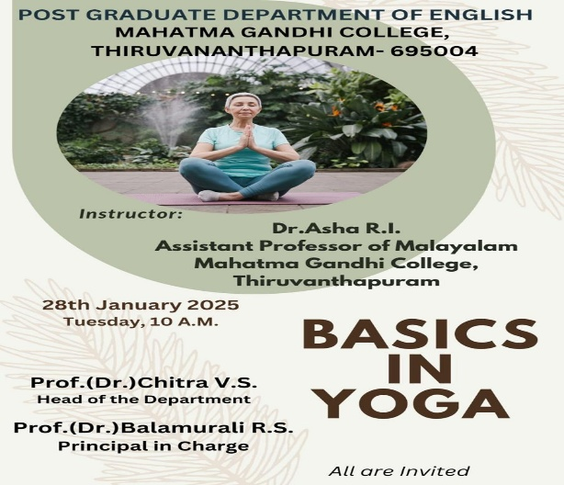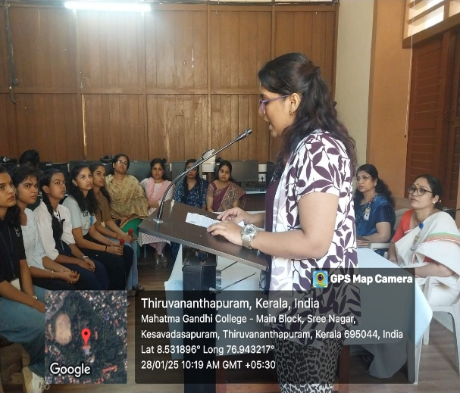

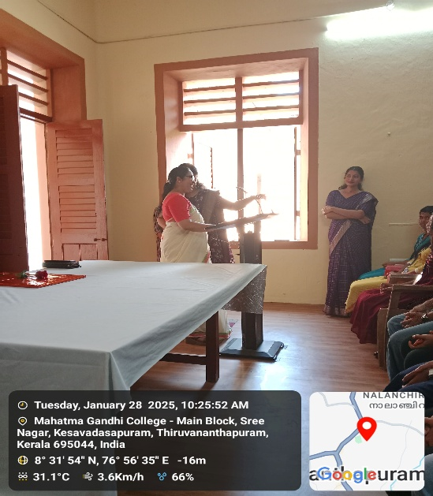 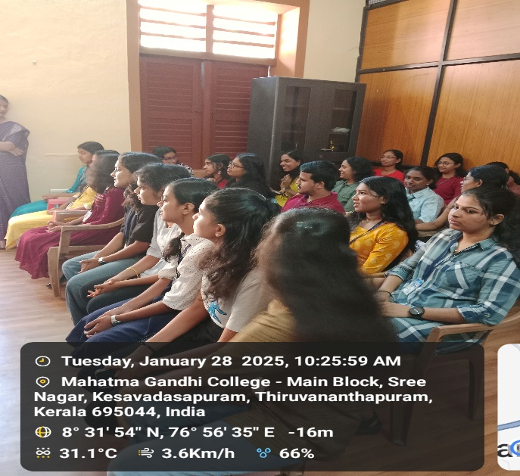

1. **Film Festival**

**Date: 5 – 7 February 2025 Venue1- Seminar Hall Venue2- Room no 74**

Film festivals conducted in colleges is important because it promotes creativity, cultural exchange, and critical thinking among students. Students learn about different cultures, perspectives, and filmmaking techniques and it also introduces students to different film genres, including documentaries, animation, and experimental films. They depict social issues, inspiring discussions and action among students. They can also be a tool for spreading awareness about important topics like mental health, environment, or social justice. With these objectives the department conducted a film festival which was fully coordinated by the students.

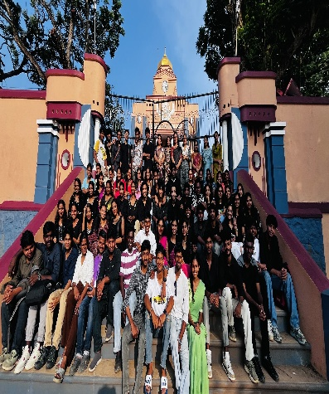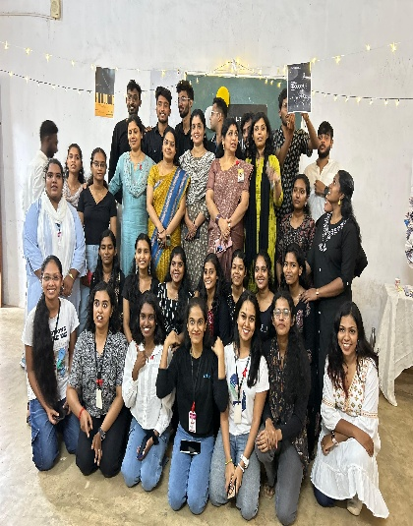

1. **Photography and Reel Competition**

**Date: 06/0202025 Venue: College Campus**

Engaging in modern-day activities like photography and reel-making is significant because it enhances creativity, improves technical skills, and helps in personal and professional growth. Photography and reel-making allow individuals to capture moments, emotions, and stories in unique ways. They help in developing a creative eye for composition, colours, as well as helps to develop the skill of storytelling. Digital media skills are valuable in fields like marketing, journalism, filmmaking, and graphic design. These are activities which if nurtured appropriately have the capability to turn photography and reel-making into careers as influencers, bloggers, or content creators. Keeping up with trends in photography and reels encourages continuous learning and adapting to new technologies and styles makes students more flexible in the digital world.

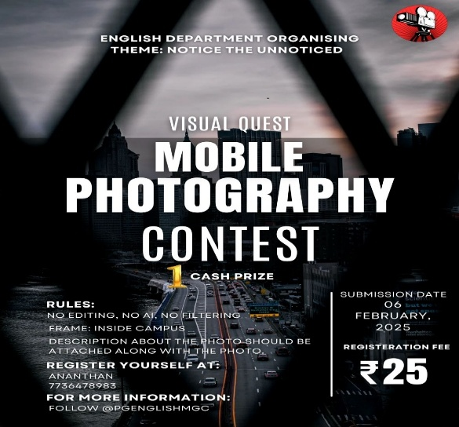 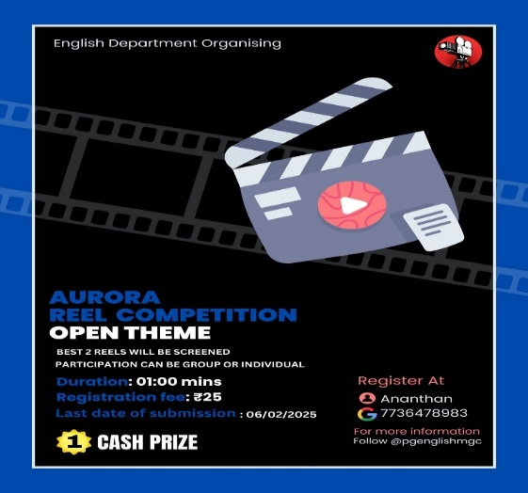

1. **Communication Skills for the 21st Century**

**Date: 11/02/2025 Venue: Seminar Hall**

The session was taken by Dr Sonia J Nair, Associate Professor and Head, Department of English, All saints College, Trivandrum. Her style was interactive and activity based through which she communicated very effectively that in the 21st century, effective communication skills are essential for success in both personal and professional life. With rapid advancements in technology, digital communication has become just as important as verbal and written skills. Key skills include active listening, clarity in expression, adaptability, and emotional intelligence. The ability to collaborate in diverse environments, use digital platforms efficiently, and practice critical thinking is crucial. Non-verbal cues, such as body language and tone, also play a vital role in conveying messages effectively. In an era of globalization and instant connectivity, strong communication skills foster better relationships, teamwork, and problem-solving abilities, making them indispensable for personal growth and career success.

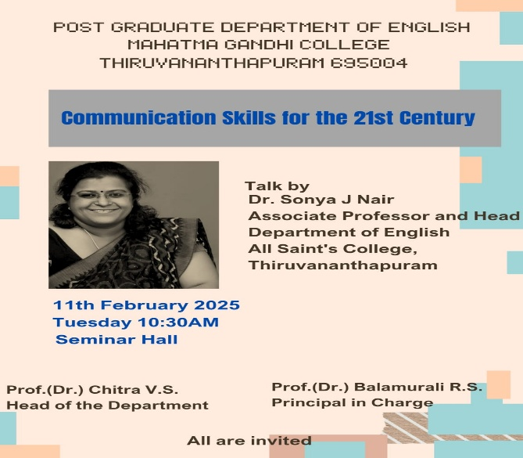 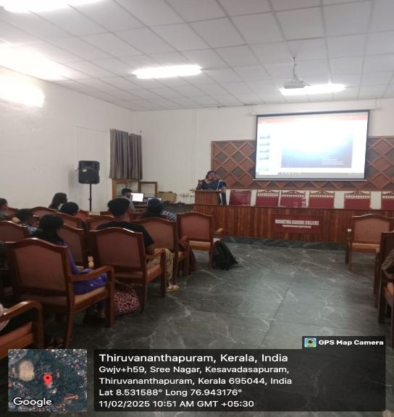

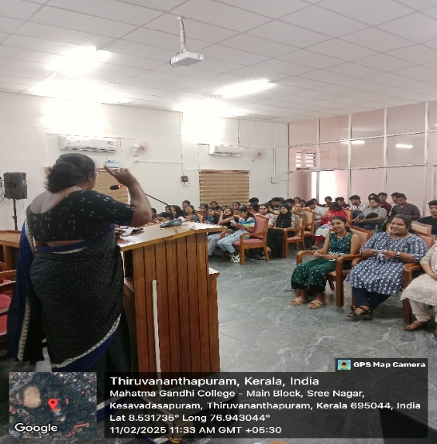 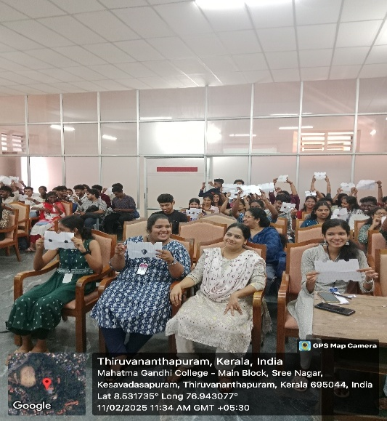

1. **Creative skill enhancement workshop: Fabric painting for Beginners**

**Date: 01/03/2025 Venue: Room No 74**

As part of Department’s skill enhancement program a Fabric painting class was conducted for the students. They were given a hands on training by the Fevycryl expert Ms Rekha Anilkumar. The students were provided with colour and material required for the session and they were given training in fabric painting. The students were also allowed to keep the finished products. Though the session was primarily intended for girl students on request by boys this was conducted as a gender sensitisation program and boys were also allowed to participate.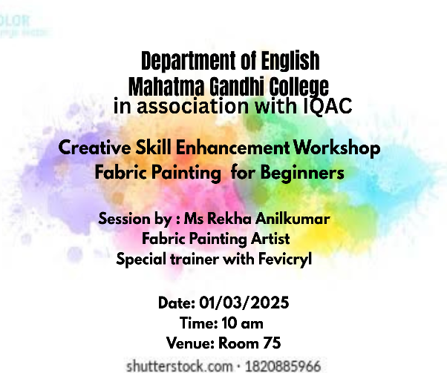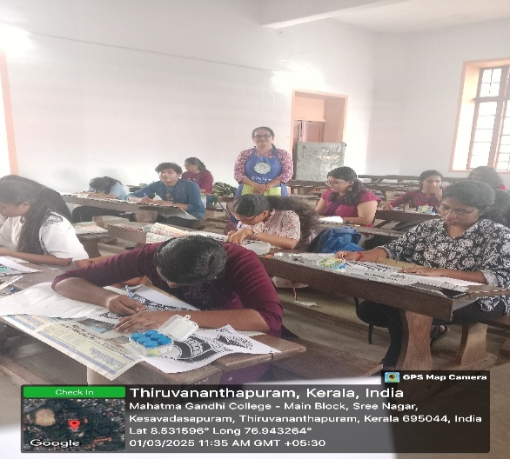

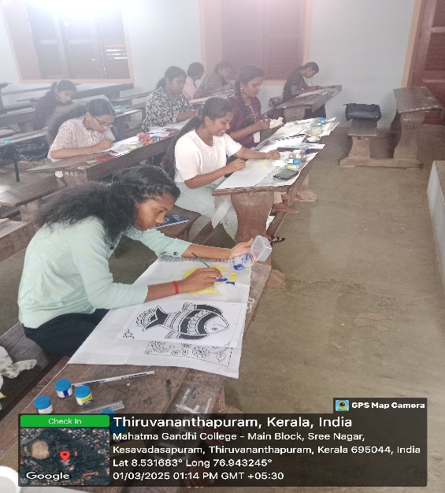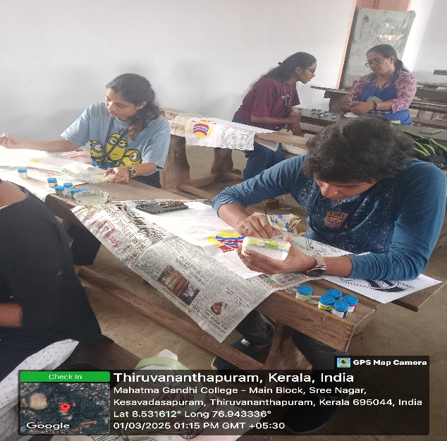

1. **Career readiness in the AI Age**

**Date- 04/03/2025 Venue: Seminar Hall**

A career guidance and relevance class was conducted for the student members of the women’s study unit as well as other students of final year UG and PG. The session engaged by Dr K P Jaikiran, Former Associate Professor and Head, Department of Geology, University of Kerala was extremely informative as well as usefull for the students. The students were able to understand the current areas were the significance of AI is increasing and various online courses which the students can do in order to strengthen their resume and get higher chances of recruitment.

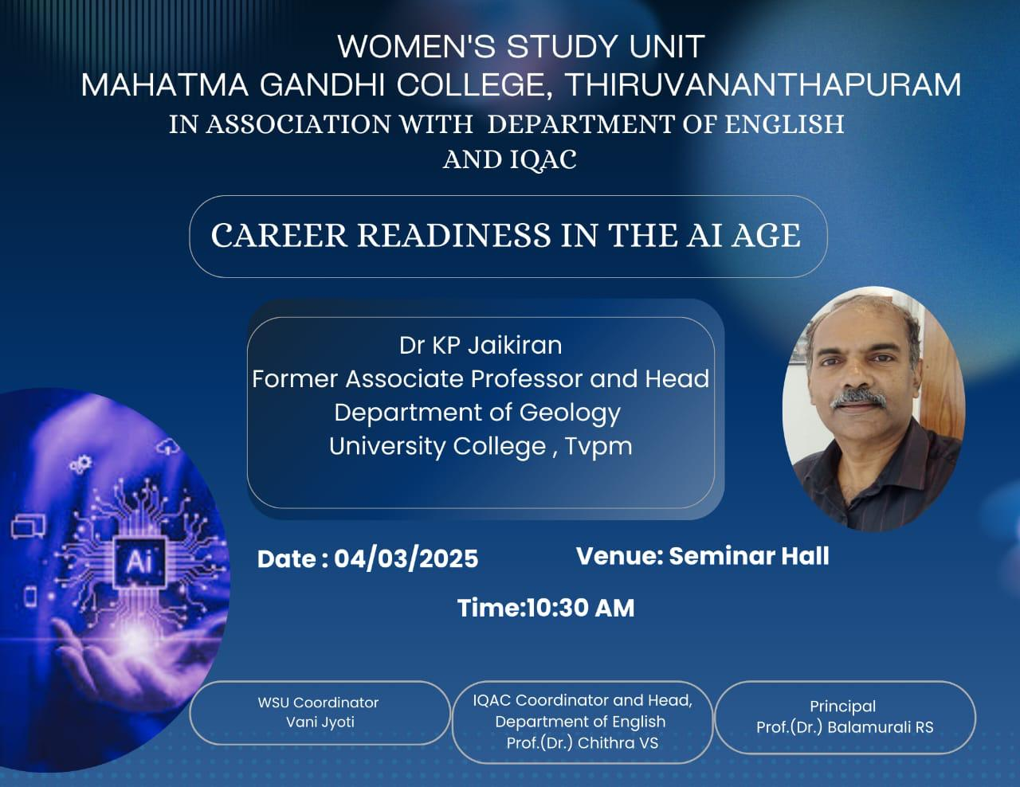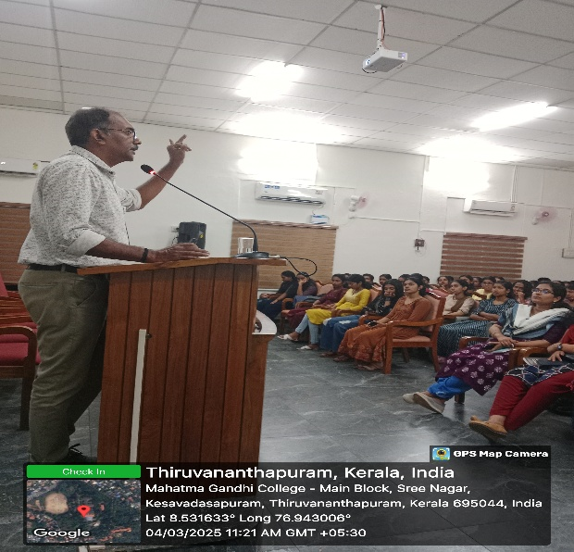

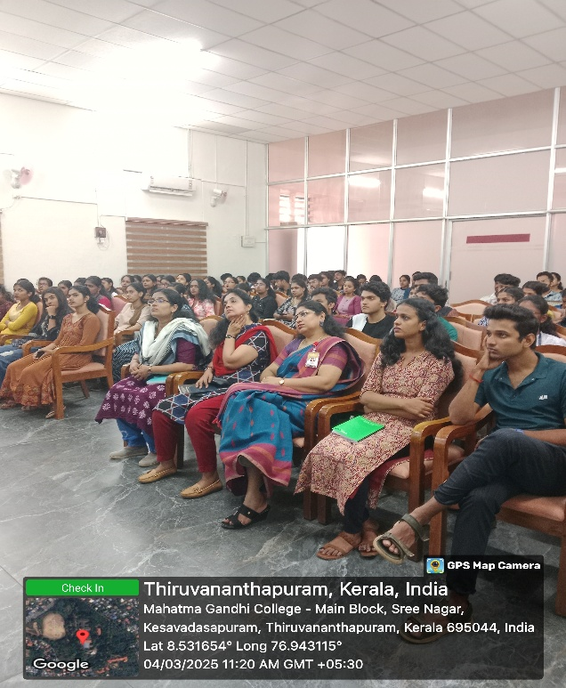

1. **Felicitation of the UGC NET/JRF,PhD 2025 awardees and Rank Holders 2024-25**

Felicitating the success and achievements of our students is an acknowledgement of their hard work and efforts as well as an inspiration to the students to strive harder to attain similar achievements and goals. The success of students is also a source of great happiness for the teachers who have been facilitators in their journey of attaining knowledge. With this aim the felicitation ceremony of the Rank holders of the post graduate English degree students and the JRF /NET, PhdD holders was conducted.

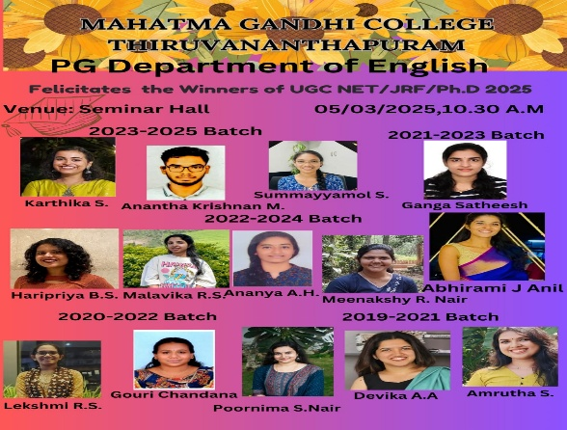 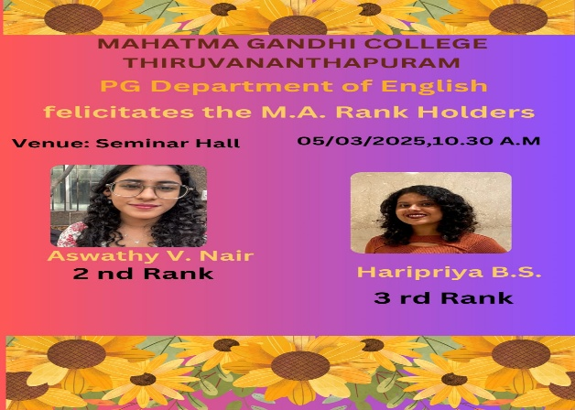

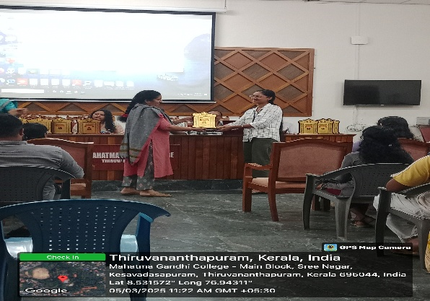 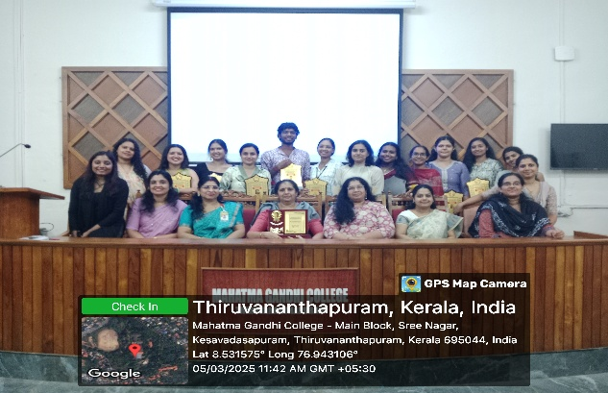

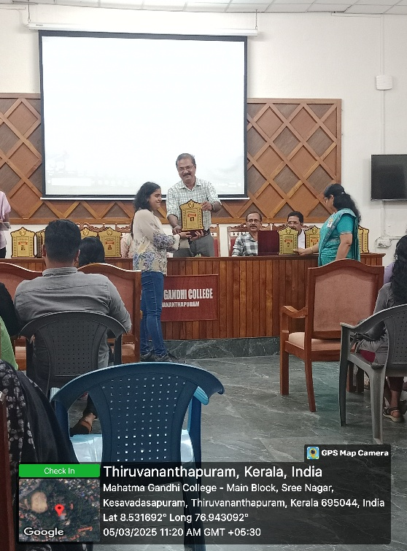

1. **Climate Resilience: Life as told by women**

**Date: 11/03/2025 Venue: Seminar Hall**

Climate resilience refers to the ability of individuals, communities, and ecosystems to anticipate, adapt to, and recover from the adverse impacts of climate change. It involves strengthening infrastructure, promoting sustainable practices, and developing policies that reduce vulnerability to extreme weather events like floods, droughts, and hurricanes. Key strategies include disaster preparedness, eco-friendly urban planning, renewable energy adoption, and biodiversity conservation. By building resilience, societies can minimize risks, protect natural resources, and ensure a sustainable future for generations to come. This very relevant area is documented from the point of view of women in the documentary director Bindu Sajan and Sajan Gopalan. Their documentary was screened and the students got to interact with these directors and get a first hand narration of their experience.

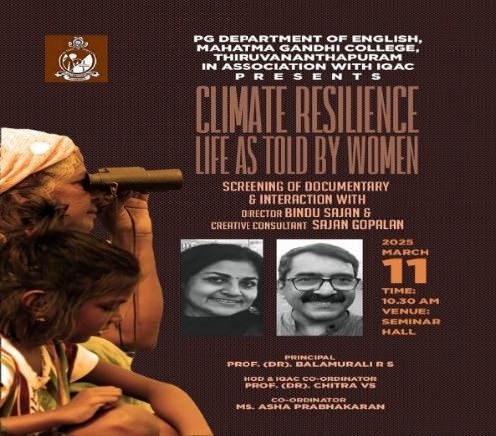 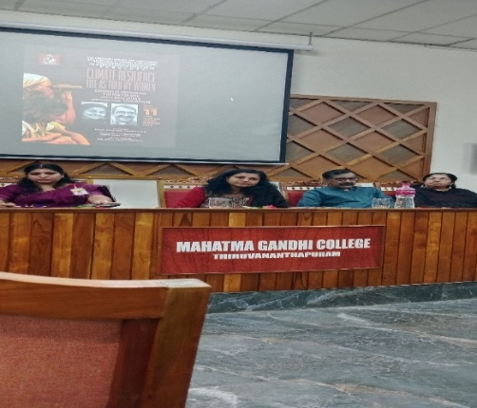

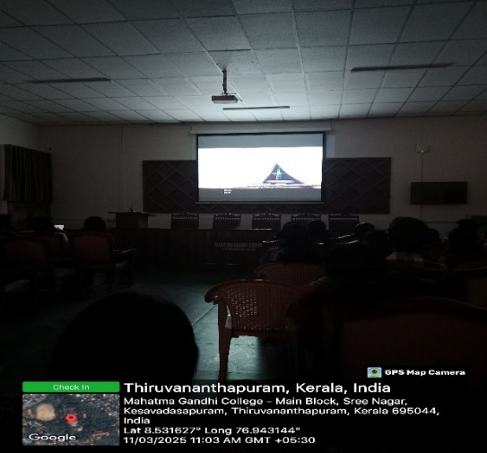 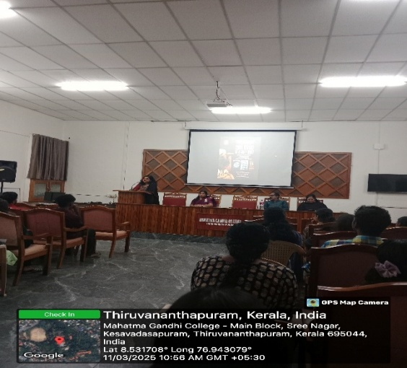

1. **Bene Jewish Poetry Reading Session**

**Date: 10/3/2025 Venue: Seminar Hall**

Ms Zilka Joseph an Indian Born Poet and writer now settled in Michigan writes about the bene Israel Jews of India. She talked about who they were, where they came from, how they survived and where they are now. She gave an overview of the three Jewish Communities in India, with a focus on the history of the most ancient community called the Bene Israel. The poet herself belongs to this ancient community and she read poems from her collection of poetry titled “*Sweet Malida: Memories of a Bene Israel Woman”.*through these poems she discussed her own stories of food, memory, imagination and her Bene Israel connection. The session was an experience of a understanding the origin and survival of a community which was possible only in a Country like India which has been home to diverse ancient cultures and religion.

